Instructions For Running a DLM Test Administration Monitoring Report

- Login to the Educator Portal (https://educator.cete.us/AART/userHome.htm)

- Click on Reports :
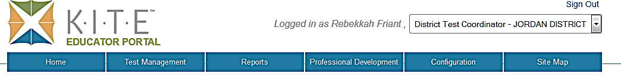

- Click on Data Extracts: 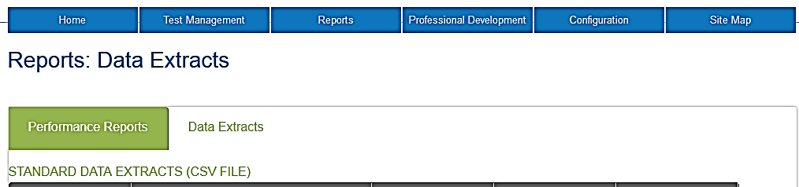

- A list of different reports will come up for you to choose to print. Choose,
DLM Test Administration Monitoring:

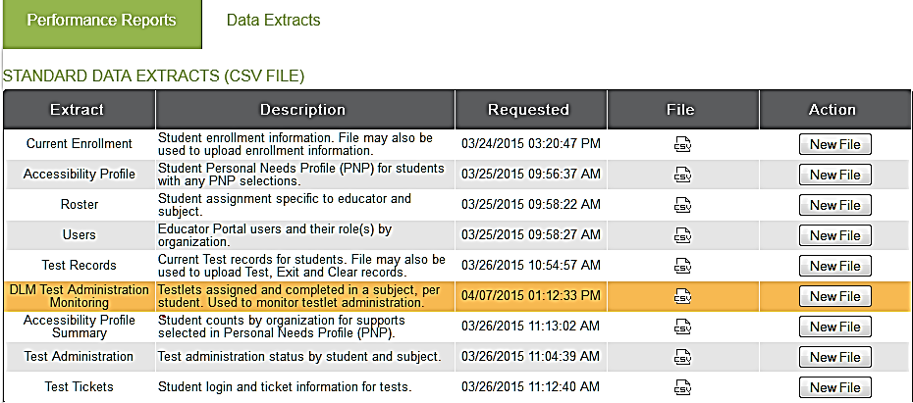

- Click on New File:
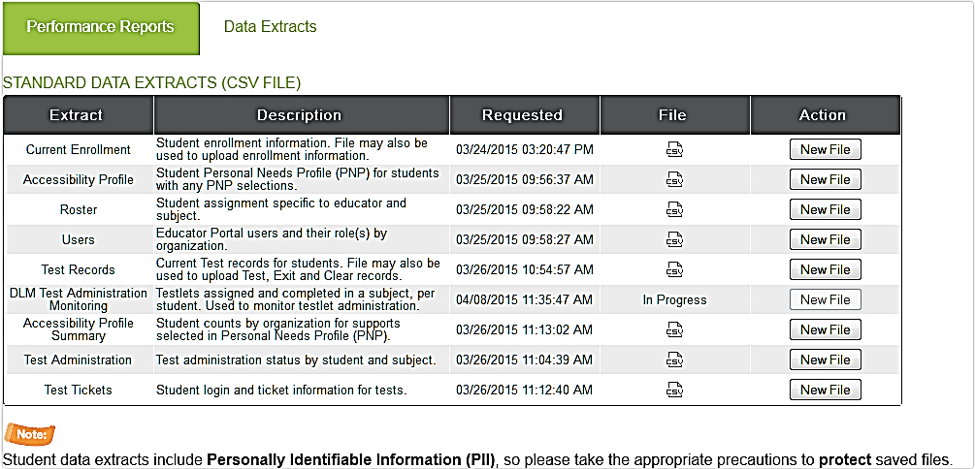

- A new screen will come up asking for extract date information. You will need to fill in the beginning and ending dates for instructional and end of year. You will need to choose dates for all four filters. You can put in the same dates for Instructional and End of Year. (Your school name should come up in the School Box).
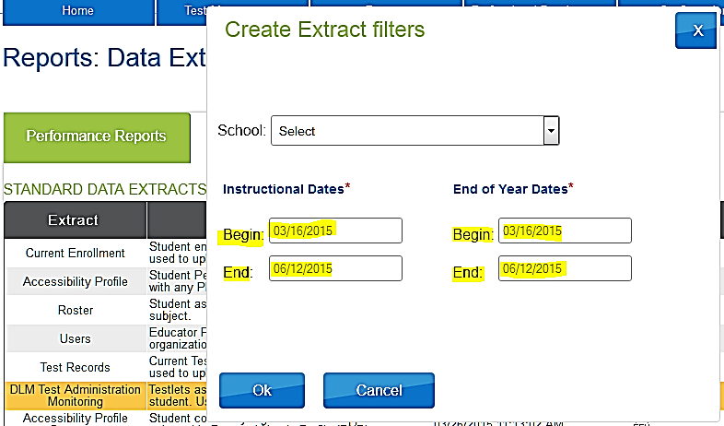

- Click Ok:

- When the system is processing the report, the File Column will display In Progress.
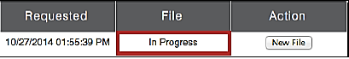

- When the file is generated, a CSV icon will display. Click on the CSV icon. 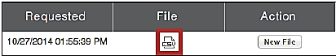

- After clicking on the icon, a page will pop up similar to this one:

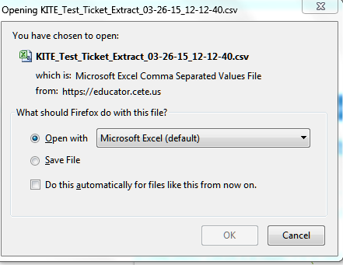
The file name will be KITE_DLM_Test_Administration_Status_Extract_MM-DD-YY_HH-MM-SS.csv. (MM-DD-YY is the month, day, and year you ran the extract. HH-MM-SS is the hour, minute, and second you ran the extract.)

- Click Save File

- Every time you run a new report, the existing report will be deleted. (This is why it is a good idea to save the reports to your computer each time).

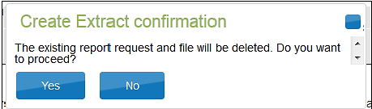

- When you open up the Report, it will be in EXCEL.

- Below, is an explanation for the columns that will be listed on the Spreadsheet? You will not need to worry about the columns with Instructional Data. (You can hide these columns to make the spreadsheet easier to read).

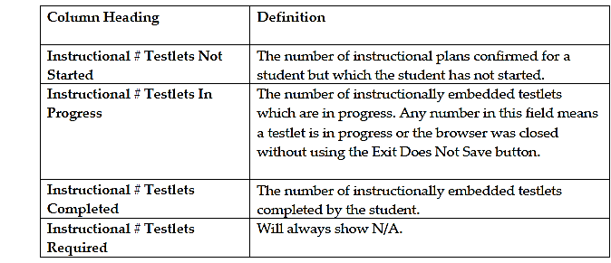

- The following explanations are the End of Year columns that you will need to track your student’s progress.
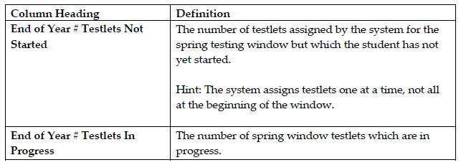
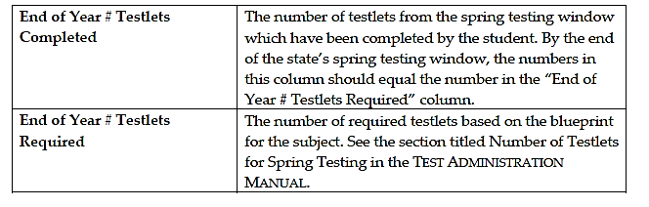
Below is the list of the Number of Testlets for Spring Testing:
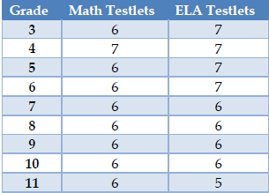
The KITE system will not tell the student when they have finished taking all of the Testlets for each subject. You will know when no new testlets show up for them in the Educator Portal. Another way to know when a student is finished testing is by running the DLM Test Administration Monitoring Report.
If you have any questions, please contact Bekkah Friant (801-567-8112).

