Instructions for taking a Practice Activity or Released Testlet
The Kite Client (the DLM system that the students will use) should be installed on the computers at your school. Please check with your school tech to see where it was installed. If it has not been installed, please let Bekkah Friant (801-567-8112 or bekkah.friant@jordandistrict.org) and you school tech know ASAP?
Steps to open up Practice Activities (also found in the Test Administrator Manuel pg. 151-152)
- Click on the KITE Client icon on the student’s computer:

- Click the Other Assessments Card:

- A screen will come up looking like this:

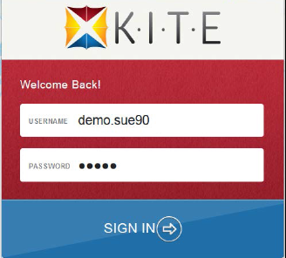

- Enter the demo student’s Username and Password from the list below. Pick the demo student’s name that has the Personal Needs supports that your student may require. This way the student will be able to practice with the supports they will be using during the Spring Test.

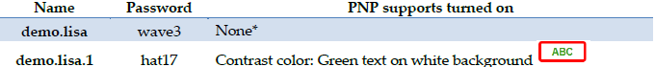
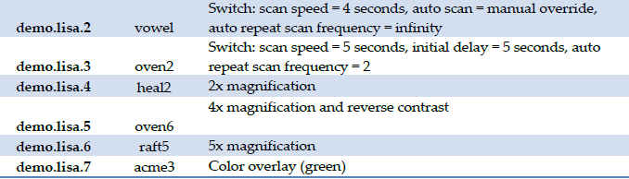

- The screen will now look like this: 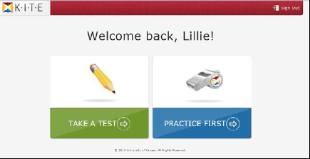

Please click on the Practice First Card. You will only click on the Take A TesT card during the Spring Testing Window. If you try and click on it now, it should not come up with any tests.
- A list of Practice Activities and Released Testlets will come up. Select the Practice Activity that you would like to try.
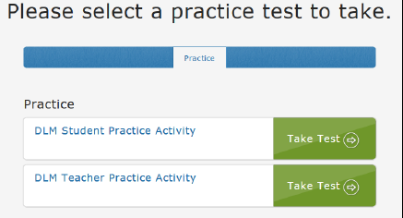

- Click BEGIN

- To navigate through the test you will use the BACK and NEXT buttons. To stop during the middle of the test you will use the EXIT DOES NOT SAVE button. This will exit the student from the test, but it will not save any of the information in the testlet. The student will have to begin the entire testlet again. (this will be the same during Spring testing)

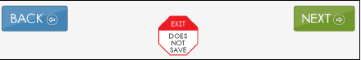

- To use a different demo student profile go back to the Welcome Screen and Sign Out, then you will need to Sign back in with a different username and password.

If you have any questions about the Practice Activities or Testlets, please contact Bekkah Friant (801-567-8112 or bekkah.friant@jordandistrict.org) in Evaluation, Research and Accountability.

