Instructions for DLM Spring Testing
In order to open up a Testlet for your students you will need to have their Username and Password. The Usernames and Passwords will be the same for the Math and English Testlets.
Follow these steps to view/print out the student’s Username and Password (information can also be found in the Test Admin Manuel pg. 118-121):
- Login to the Educator Portal in KITE found at, https://educator.cete.us/AART/logIn.htm

- Click on Test Management Card:

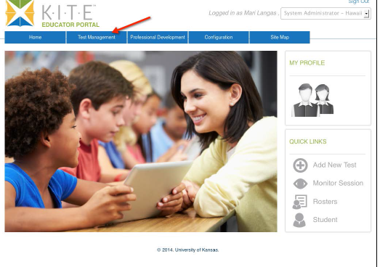

- Click on the Test Management sub-tab:

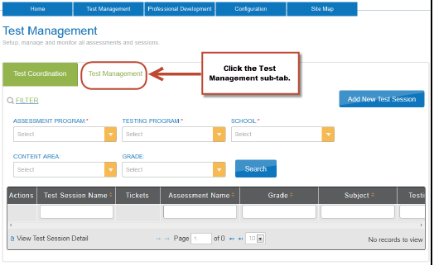

- Under the Filter you will see 5 different fields. You will need to select options in the following fields, the other fields you can leave blank:
Assessment Program: Dynamic Learning Maps
Testing Program: Summative
School: Your School
The fields that you can leave blank are: Content Area and Grade

- Click Search button for a list of test sessions.

- Click the PDF icon located next to the name of the test to see the student’s username and password.

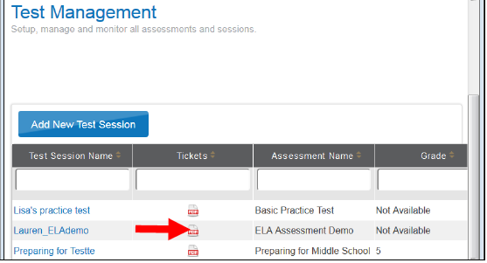

- Tests are only available during the Testing Window (3-16-15 – 6-12-15).
- You will only be able to print tickets for the students during the open testing window.
- If you can’t see tests for students after the window has started, you will need to make sure that the student is assigned to your roster.
- If the student is on your roster, but still does not show any tests, make sure that you have completed the First Contact Survey and PNP for that student.
- If you have followed these steps and still don’t see the student’s test, -then contact Bekkah Friant, 801-567-8112.
- Click Open with; select Adobe Reader: 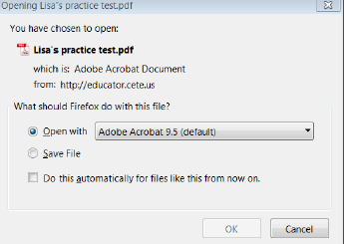

- Click OK

- The student’s ticket will then come up on your screen. At this point you can print the ticket, but please remember that it is a SECURE Document. After the Student has completed all of the Spring DLM testing, please shred the Student Ticket.

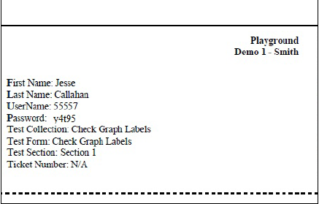

- Now you should print out the student’s Testlet Information Page (TIP). You will need to print a TIP out for each testlet your student is assigned. After the student completes a testlet a new testlet will be assigned to them within 30 min. The steps for printing the TIPS are as follows, or can be found in the TAM pgs. 122-125.

- Go back to the Home page of the Educator Portal. Click on the Test Management Card: 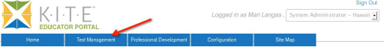

- Click on the Test Management Sub category. Fill in the fields again. 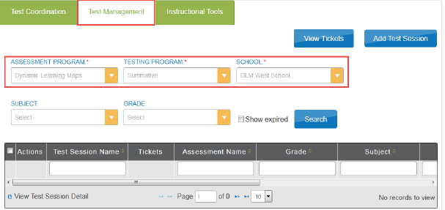

- Click Search. The list of tests sessions will be displayed.

- Click the Test Session you are looking for. The test session names are long. Look for the student’s last name and the test collection name. 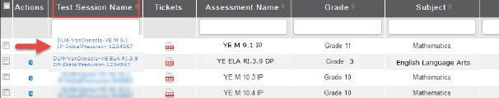

- Scroll over to the Test Information column and click the PDF to view/open the TIP. 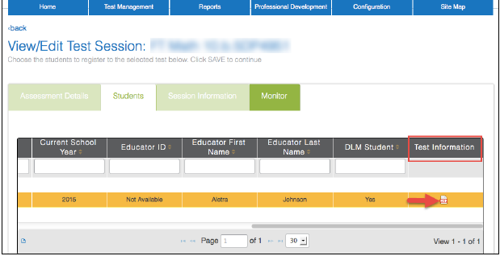

- Click Open with; choose Adobe Reader. 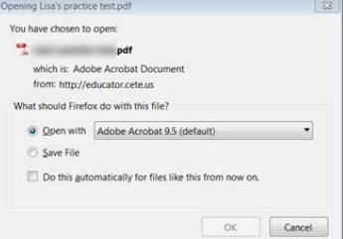

- Click OK

- At this point you can View/Print the Testlet Information Page (TIP). When printing this document, remember that it is a SECURE Document. You may only want to print the pages that you need. For the 2014-15, Spring Testing Window Screen Reader will not be available. Human Read aloud will be the only available read aloud for your students. Because of this, there may be multiple Testlet Information Pages to print out. Use the TIP to prepare for the testlet administration. When the student is finished taking each Testlet, shred the TIPS. Remember Do NOT save TIPS to your computer.

- Now you are ready to start a test for your student. The steps to open up a test are as follows or can be found in the TAM on pgs. 153-159.

- Click the KITE CLIENT on the student’s testing computer.

- Click Other Assessments. 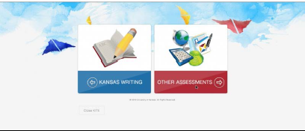

- Enter the student’s Username and Password from the ticket you printed out. 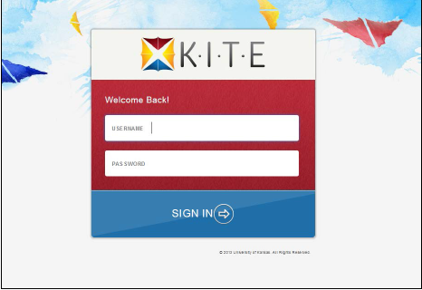
Click Sign In.

- Click Take a Test.
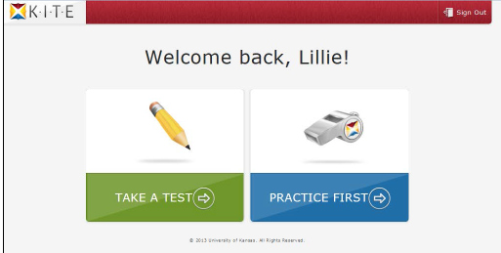

- A list of tests will come up on the screen. (you may only see one test at a time) Pick the desired test. Click Take Test.

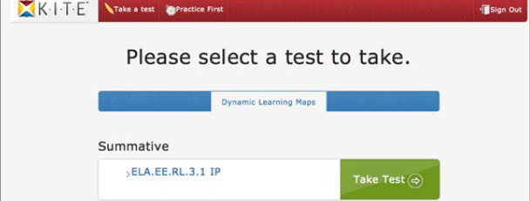

- Click Begin.

- The buttons that will be used to navigate through the system are: BACK, NEXT and EXIT Does not Save. 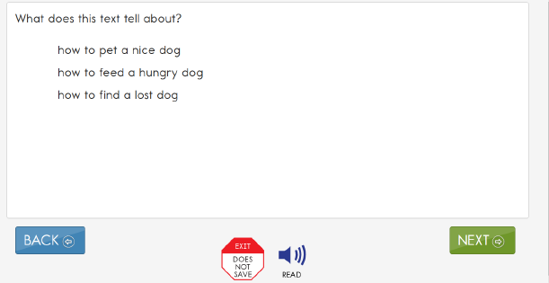
If you have chosen Read Aloud in the student’s PNP then this button will show up on each question, but for the 2014-15 Spring Testing Window the Spoken Audio is NOT available. You may use Human Read Aloud for your students!!!

- The DLM tests are not timed tests. Your students can take a break during each Testlet by following one of these 3 ways:
- Take a short break that is less than 28 minutes.
After 28.5 minutes of inactivity, the system will warn you that you have 90 seconds to click Extend Session or Logout. After 30 minutes of total inactivity, KITE will close the session automatically.

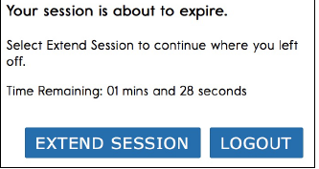

- Take a break between each Testlet.
After the student completes the testlet, you will hit End. AT this point you can log the student out of the KITE system. You can log the student back into KITE when they are ready for the next Testlet. Remember that you will need to check the Educator Portal and print out the new TIP for the next testlet.

- Stop in the middle of a test using the EXIT DOES NOT SAVE button.
This button will show up for every question.

When you click on the EXIT DOES NOT SAVE button this screen will come up:

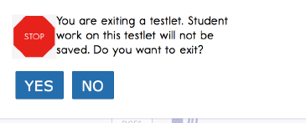

Click YES to exit the test without saving the student’s work. When the student returns to this testlet they will start at the beginning of the testlet.
Click No to continue with the testlet rather than exiting. You will then have the student continue the testlet. When they get to the end you will hit END on the review screen.

- When the student has answered the last question in the testlet, this screen will appear: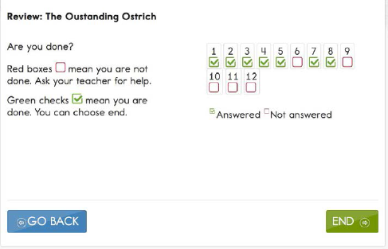

If the student did not answer a question, the box under the number will be outlined in Red. If your student has any of these boxes, please have them click GO BACK and answer the questions they missed.
The box under the numbers that are outlined in Green and have a √ means that the student is finished. If all of the boxes are outlined in Green, then the student is ready to end the testlet.

- When the student is ready to end the testlet click END.

- A message will appear that will say, “Are you sure you want to end?”
Click Yes or No. Make sure you are really ready to end the test, because you will not be able to return to this testlet if you hit YES. 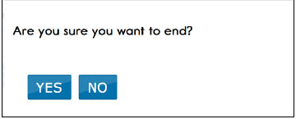

- Click Close KITE.
- A message will appear, “Are you sure you want to exit?” click YES.

If the student has taken all of the testlets for the subject (Math or English) that you are working on, then they are finished with the DLM test for that subject. Once you have tested the student on all of the testlets for both Math and English, the student will be done taking the DLM test.
The following chart shows the number of testlets to expect during the spring testing window by grade and subject.
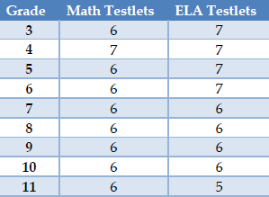
Remember that testlets contain items that are aligned to nodes at the designated linkage levels. The linkage levels are: Initial Precursor (IP), Distal Precursor (DP), Proximal Precursor (PP), Target (T) and Successor (S).
If the student is on the Initial Precursor level, then the testlet is typically administered by the teacher. All Writing testlets will be administered by the teacher. Remember to print out the TIP for each testlet so that you can prepare for the testlet, and you will know if that testlet is teacher administered. The other 4 linkage levels are typically computer-delivered testlets.

If you have any questions that have not been addressed in these instructions, please contact Bekkah Friant, 801-567-8112 or bekkah.friant@jordandistrict.org

