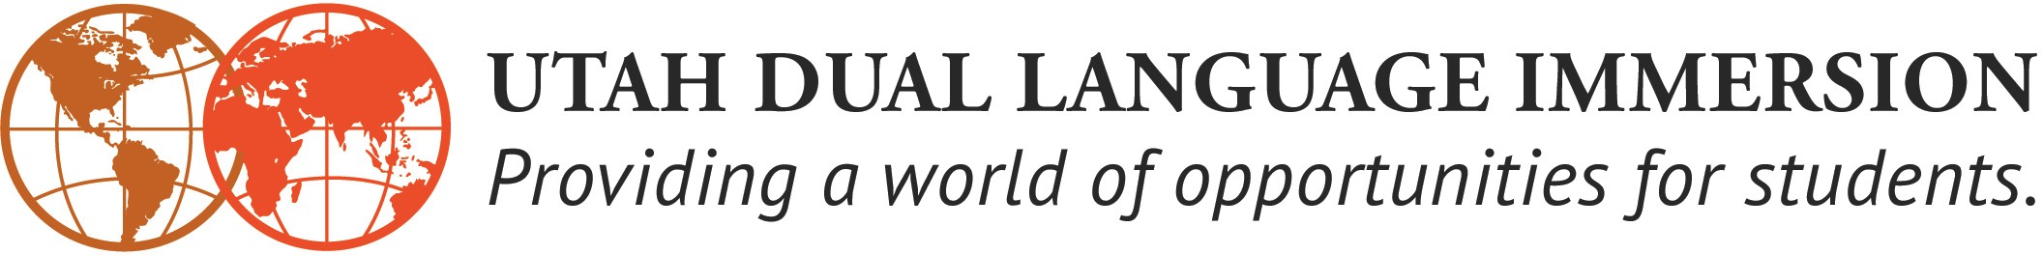
AAPPL Performance Benchmarks Grades 3-9
Official 2018
FRENCH, GERMAN, PORTUGUESE & SPANISH
Grade | Interpersonal Speaking | Interpersonal  Speaking | Interpretive  Reading | Interpretive  Reading | Interpretive  Listening | Interpretive  Listening | Presentational  Writing | Presentational  Writing
 | Meets Benchmark | Exceeds Benchmark | Meets Benchmark | Exceeds Benchmark | Meets Benchmark | Exceeds Benchmark | Meets Benchmark | Exceeds Benchmark
3 | N3 | N4
4 |  |  | N3 | N4 | N4 | I1 | N3 | N4
5 | N4 | I1
6 |  |  | I1 | I2 | I2 | I3 | I1 | I2
7 | I2 | I3
8 |  |  | I3 | I4 | I4 | I5 | I3 | I4
9 |  |  | I4 | I5 | I5 | A | I4 | I5
CHINESE AND RUSSIAN
Grade | Interpersonal Speaking | Interpersonal  Speaking | Interpretive  Reading | Interpretive  Reading | Interpretive  Listening | Interpretive  Listening | Presentational  Writing | Presentational  Writing
 | Meets Benchmark | Exceeds Benchmark | Meets Benchmark | Exceeds Benchmark | Meets Benchmark | Exceeds Benchmark | Meets Benchmark | Exceeds Benchmark
3 | N2 | N3
4 |  |  | N2 | N3 | N3 | N4 | N2 | N3
5 | N3 | N4
6 |  |  | N4 | I1 | I1 | I2 | N4 | I1
7 | I1 | I2
8 |  |  | I2 | I3 | I3 | I4 | I2 | I3
9 |  |  | I3 | I4 | I4 | I5 | I3 | I4
Assessment taken in the Fall of each year. Revised August 2018

